Measuring Voltage of a Series of Metals Based on Reduction Potential

Ellie Gervais and Lia Henriksen
May 2015
Animas High School

ABSTRACT

The purpose of this lab was to test a series of metals in a battery to indicate which metal creates the highest amount of voltage when paired with iron. Iron was kept as a constant variable in the circuit for the sake of keeping the experiment consistent. Tin, copper, nickel, zinc, and aluminum were each wired to a voltmeter on the opposite sides of a vinegar soaked towel with iron wired to the voltmeter on the other side. Volts and current produced for each metal paired with iron were measured. Results showed that aluminum produced the most amount of power (24.8 milliwatts) when paired with iron to make a battery, while tin produced the lowest, which was expected based on theoretical reduction potentials. In order to determine the amount of power that was produced, the voltage and current is multiplied, and the product of that determines the amount of power. These results clearly imply that aluminum paired with iron, within the constraints of this experiment, creates the most powerful battery. Other combinations of metals outside this experiment surely create better batteries, such as lithium and fluorine, as they are the farthest apart on a standard reduction potential table. It is possible that results for the experiment were skewed, because the theoretical voltage was much different from experimental data found in the lab.

INTRODUCTION

One of the greatest inventions in the last 400 years has been the development of electricity. Specifically, the invention of the battery has propelled us in innovation and has assisted technological breakthroughs in recent history. A scientist named Alessandro Volta first created the battery. He created the battery by layering metal disks on top of one another, separated by a cloth or piece of cardboard soaked in brine. We performed a similar experiment as Alessandro. Batteries have provided us with a portable source of energy, making several of our modern conveniences possible. Despite the multiple types of batteries that exist, they all share a basic concept: Electricity is a flow of electrons moving through a conductor, and when a circuit is completed it allows a reaction to occur. This reaction is refereed to as an electrochemical reaction. A battery undergoes a series of electrochemical reactions between the anode, cathode and electrolyte. The electrolyte completes the circuit by allowing ions between the anode and cathode to pass through it (see Figure 1). The anode goes through an oxidation reaction, while the cathode goes through a reduction reaction. An oxidation reaction is when the atom loses an electron and becomes an ion. A reduction reaction is the process of gaining electrons, and again, results in becoming an ion. For our experiment, the anode and cathode varied for each trial. Zinc, Aluminum, Tin, and Nickel all served as the cathode, while Iron served as the anode. This is because these particular metals fall under iron on the Standard Reduction Table (see Table 2), meaning they are more likely to reduce. Copper on the other hand, served as the cathode, while iron served as the anode because copper is above iron on the Standard Reduction Table (see Table 2). This means that copper is more likely to oxidize. When the circuit is complete it creates energy that is then transferred into electricity. The electricity that this reaction produces has served our portable society and our need for power for centuries.

This experiment will teach us the process of energy production through a battery. We will also learn how to record the volts and current with a voltmeter, and understand the best metals to create an effective battery.

Figure 1: Diagram of Electrolyte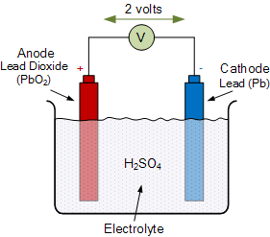

METHODS

Six different metal strips were obtained, with iron used as a constant, as it was the most neutral metal on the reduction potential chart available to us. A paper towel was soaked in vinegar in order to create an electrolyte for the reaction, but could be replaced by a different diluted acid to achieve a similar process. Mini jumper cables clipped to a strip of iron (the constant variable) and to a soaked paper towel. Cables also clipped to the experimental (dependent variable) metal to the other side of the towel, taking care not to touch the iron strip on the other side. Cables were attached to a voltmeter to create a battery. Volts and current produced were recorded for the combination of the two metals. These steps were repeated for each metal used (always combined with iron). The metals represented the cathode and anode, depending on whether they were more likely to oxidize or reduce when the reaction occurred.

Figure 2: Experimental Set-up

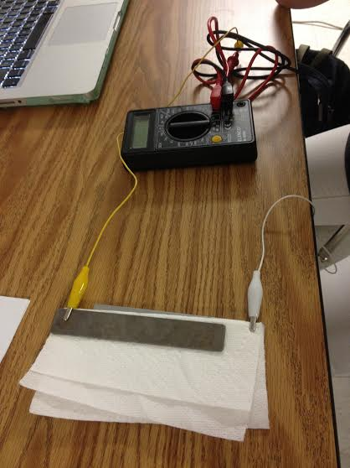

HAZARDS

This experiment posed no real hazards to scientists, as all materials could be handled safely with little to no protective gear used. Certain metals pose potential allergy hazards such as irritating skin and eyes. For the most part the lab can be performed safely without protective gear or material.

RESULTS

In order to test which combination of metals created the battery with the highest voltage, data was collected that measured voltage and current for each combination of metals in a circuit. Aluminum produced the highest amount of power experimentally (24.8 milliwatts) and the highest voltage theoretically (1.66 volts), which means that our results were, for the most part, accurate (Table 1). Current produced was also tested for each combination, and measured with the same trends that voltage followed (aluminum produced 40 milliamps, which was the highest of all the combinations). Tin produced the lowest amount of power (0.12 milliwatts), meaning that it also produced the lowest voltage and current (voltage being 0.043 volts and current being 0.24 milliamps). Figure 2 compares these results. According to Table 3, the expected vs. experimental results for predicting which metal would create the most successful battery did not exactly match up. Although aluminum was the best metal to be paired with iron for both categories, and tin was the least successful, results varied as the list continued. Values for zinc, copper, and nickel did not match between the theoretical and experimental results. One factor that should be taken into consideration is how distinct the difference between the theoretical and experimental data values recorded are. Although aluminum still had the highest voltage for both categories by ratio, the values themselves did not match up well.

Table 1: Theoretical and Experimental Voltage
Metal paired with Fe | Voltage produced (V) | Theoretical voltage produced (V) | Current produced (mA) | Power  Produced (V*mA)  (mW)
Tin | .043 | .104 | .28 | 0.12
Zinc | .113 | .724 | 15.9 | 1.78
Aluminum | .62 | 1.66 | 40 | 24.8
Copper | .523 | .376 | 2.8 | 1.46
Nickel | .280 | .214 | 7.15 | 2.00

Figure 3: Standard Reduction Potentials
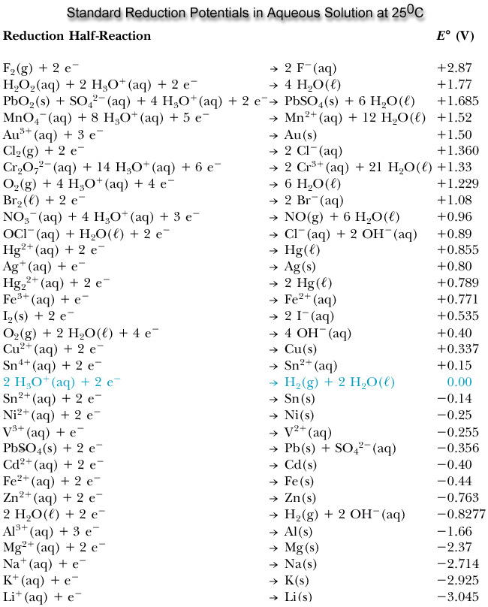

Table 3: Theoretical vs. Actual Best Battery Metals
Theoretical Order for Best Battery | Actual Order for Best Battery
Aluminum | Aluminum
Zinc | Copper
Copper | Nickel
Nickel | Zinc
Tin | Tin

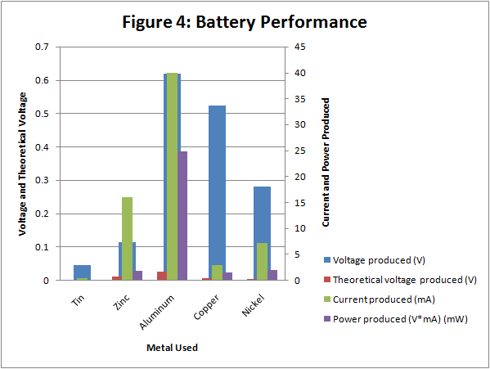

DISCUSSION

The purpose of this experiment was to determine which metal combined with iron created the most powerful battery. Expected results were that aluminum and iron would result in the highest voltage battery. Experimental results proved that aluminum was in fact the most effective metal to be paired with iron to achieve the most powerful battery, even if the rest of the metals didn’t exactly match up theoretically and experimentally (Table 3). Possible reasoning for this occurrence could have been inconsistencies with reading the voltmeter. Table 1 displays that aluminum created the highest voltage while tin created the lowest. Data found on a standard reduction potential table proves that aluminum and iron should produced the expected results because they are the furthest apart out of the metals tested in this experiment. Tin and iron were the closest on the standard reduction potential table, resulting in the least amount of voltage.

This experiment may have been more successful if a more neutral metal would have been used for the constant variable such as copper. This would have allowed us to have a more comprehensible set of data that would have provided more insight for a powerful battery. At first glance, percent error was high, but when experimental values were compared to theoretical values, results were correct. This could have been misinterpreted, as individual results for experimental and theoretical results were not necessarily the same numbers, but were ranked in the same order. However, steps taken to achieve results closer to the theoretical values could have been using more consistency when recording units (instead of recording volts and millivolts, record only volts), or soaking the paper towel more frequently to create the exact same conditions for each measurement. Furthermore, results for power produces were most likely skewed because the results for current produced were relatively skewed. Power produced was found by multiplying voltage and current. We are somewhat skeptical about our results, as we believe that source of error was initiated by our lack of experience with reading a voltameter. We could have improved this lab by having a more in depth understanding of batteries and measurement of electricity to begin with.

These results were not necessarily applicable to the real world because we did not have access to the theoretically successful pairs of metals. However, it gave us insight as to why certain pairs of substances create good batteries, such as fluorine and lithium. Within the restraints of the experiment we were able to learn about the voltage that these particular metals would create, which serves importance in our understanding of battery power and energy as a whole. Portable energy has become an essential part of modern society, and learning to create long-lasting, powerful sources of it is becoming more and more important. Although our experiment did not directly apply, the same basic idea can be applied to actual labs attempting to produce similar results with more unusual metals. We hope to see further improvements to battery innovation in the near future.

