Exploring the Relationship Between Matter and Light and Identifying Unknowns through Flame Tests and Spectroscopy
By Ellie Gervais

Introduction:
The purpose of this lab was to understand the Bohr model of the atom, explore the relationship between matter and light, and identify unknowns through flame tests and spectroscopy. The Bohr model of the atom, composed by Niels Bohr, is a representation of the electrons orbiting the nucleus at fixed distances. The model also represents the nucleus as positively charged. Electrons absorb energy when a particular type of photon hits them. The electron will absorb the photon and move about the atom, and then release another photon and return to its original ring around the nucleus. The quantum mechanical model of the atom is based on probability, it uses more complex shapes of the orbital’s, and suggests the atom is more like a cloud. The Bohr model is widely accepted and more well known than the quantum mechanical model, but the quantum mechanical model is a more accurate representation of the atom.

Furthermore, many theorists and scientists have contributed to our understanding of the atomic structure. Some theories have been proven untrue, like the idea that atoms are solid balls of mass, and have been replaced with refined conceptions, such as atoms being more like “clouds”. Today, we accept that atoms combine in simple whole number ratios to make compounds. We have also discovered and accepted that electrons exert negative charge, protons exert positive charge, and that electrons orbit the nucleus.

A direct relationship exists between energy and light photons. The relationship is that the more energy present, the higher the frequency is of the photons. Therefore, the higher the frequency, the closer the light is to ultra violet on the spectrum. The lower the frequency, the closer it is to infrared on the spectrum. Every element has a unique atomic structure; therefore it has a unique frequency, which creates an individual spectrum emission line for that atom. Spectrum emission lines are visual representations of the frequencies of electromagnetic radiation that are omitted from an atom. That energy is released in the form of a photon when an atom transitions from a high-energy state to a low energy state. The unique spectrum pattern created by each element, allows us to use spectroscopy to identify unknown substances and discover new substances. Flame tests are methods used to identify matter based on its relationship with light. Flame tests allow us to compare the color omitted from the flame to substances that we are already familiar with that might share similar compositions with the unknown substance.

Spectroscopy allows for the measurement of spectra and is created by the electromagnetic radiation emitted by an atom. A spectrometer is a tool used for measuring spectra as a method of analysis, while a spectroscope is a device used to record the spectra for examination purposes. A spectrometer splits up light into its individual wavelengths, (see Figure 1.) An example of this is when white light hits a prism; the light splits up into a rainbow.
Figure 1: Diagram of a spectrometer
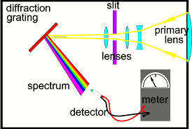

Spectroscopy can be used in a variety of ways. One field where spectroscopy is useful in law enforcement and criminal investigation. It can be used to identify unknown substances, such as illegal drugs, and can determine the composition of new drugs, unknown to law enforcement. According to Konica Minolta, the sale of counterfeit drugs via the internet is a growing problem. Law enforcement can use spectroscopy in order to detect counterfeit drugs before they become available on the street. These counterfeit drugs often contain life threatening toxins. Spectroscopy has been around for a long time, but its applications continue to expand.

Results:

Part I Qualitative Investigation

Table 1: Substance and Flame Color
Solution | Flame Color
Control | Green
NaCl | Orange
CuCl² | Green
LiCl | Red/Orange/Purple
KCl | Pink/Purple/Orange
CaCl² | Orange
SrCl² | Primarily Red/blue
CaCO3 | Orange/Blue
Na2CO3 | Orange
K2SO4 | Pink
CaSO4 | Light Blue/Orange
Unknown 1 | Light Blue/Orange
Unknown 2 | Purple/Pink

Part I Discussion:

The purpose of this lab was to explore the relationship between matter and light and to identify unknown substances through the process of flame testing and spectroscopy. It was expected that each substance would create a unique color in the flame. Because there is a direct relationship between matter and light and every compound has a unique frequency, unknown substances could be identified using flames tests. The elements tested with Ca (Calcium) in them appeared to have a mixture of blue and orange flame, which was nearly identical to Unknown 1. When Unknown 1 was lit, the flame was orange and blue as well. Therefore, it can be inferred that Unknown 1 had Ca (Calcium) in it (Table 1). When Unknown 2 was lit, the flame appeared to be primarily pink, and somewhat purple. The elements tested with K (Potassium) all presented a pink flame with traces of purple.It is safe to conclude that Unknown 2 had K (Potassium) in it. There is assurance in these results because the elements that were lit emitted vibrant colors that were consistent with its corresponding element.

The outcome of these results proves that cations (metals) are able to alter the color of the flame, while anions (non-metals) do not. The anion Chlorine presented inconsistency with the color of the flame, implying that it does not have the ability to determine flame color (See table 1). When a substance containing chlorine was lit, the colors varied. When the metal elements such as K (Potassium) were lit, the colors were consistent and predictable which advocates for the fact that metal can determine flame color (Table 1).

Part II Spectrometer

Results:

Table 2: Compound Name and Wavelengths Observed
Name of Compound | Shortest Wavelength (nm) | Longest Wavelength (nm) | Other Wavelength (nm) | Other Wavelength (nm)
SrCl² | 590.0 | 683.0 | 605.7 | 670.8
NaCl | 586 | 592
KCl | 589.2 | 773.1
LiCl |  |  | 670.8
Unknow 3 | 605.7 | 772.3 | 683 | 670.8

Data: Intensity vs. Wavelength Charts
(X-axis= Wavelength, Y-axis= Intensity)

Figure 2: Intensity vs. Wavelength for SrCl ²
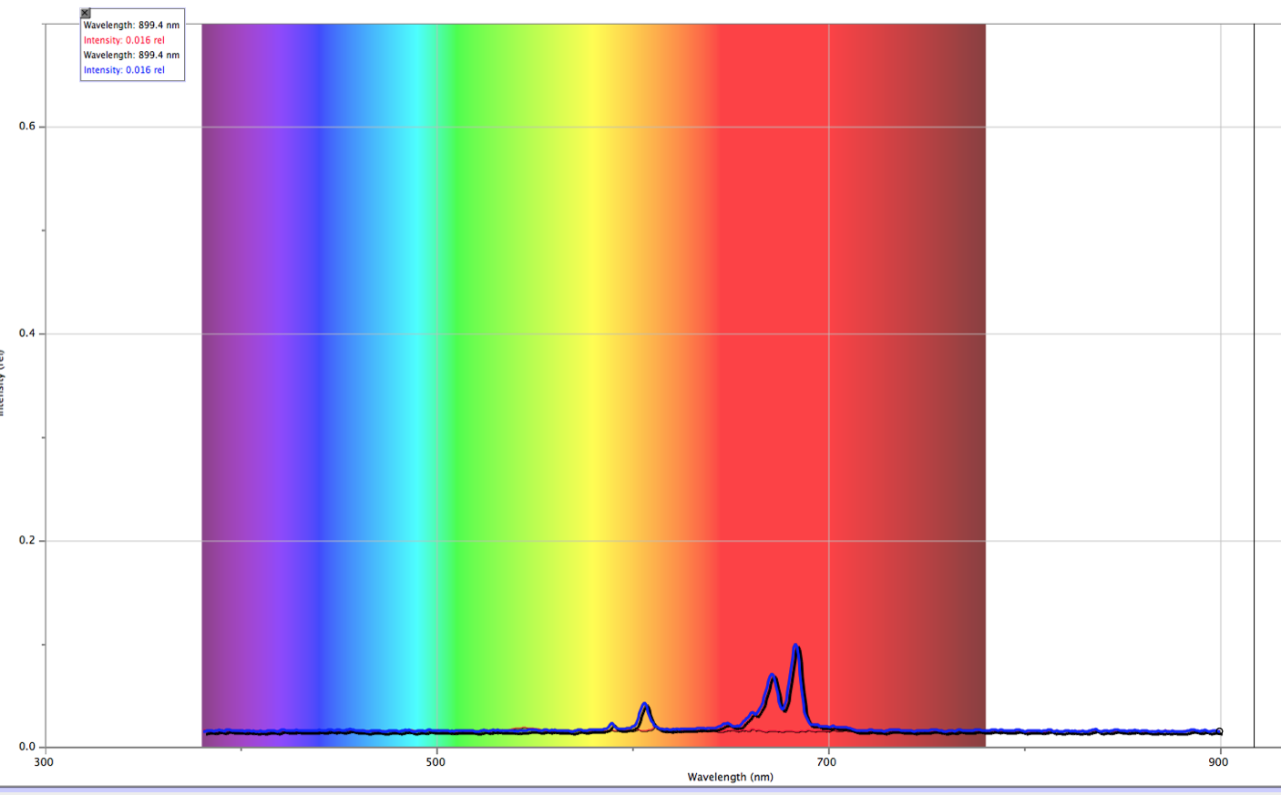

Figure 3: Intensity vs. Wavelength for NaCl
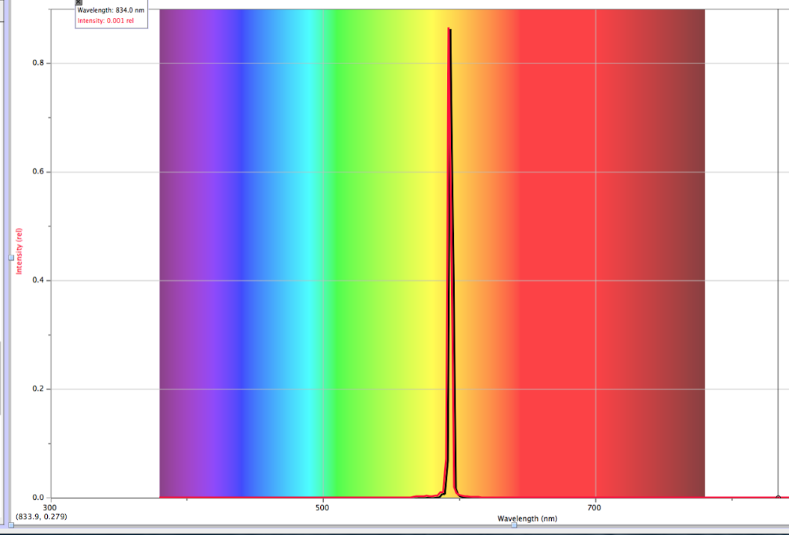

Figure 4: Intensity vs. Wavelength for KCl
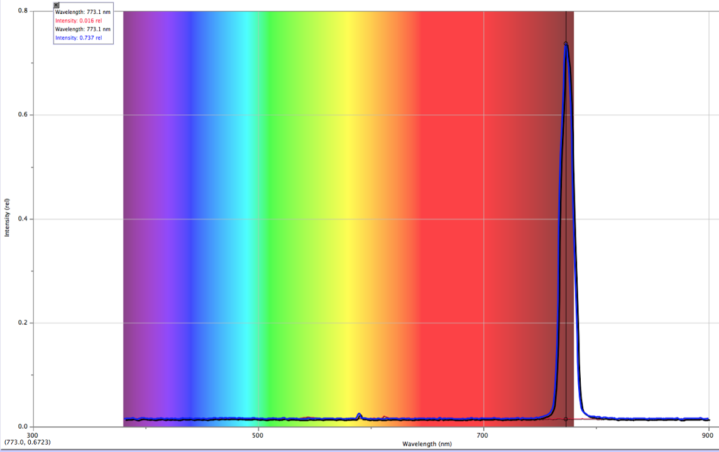

Figure 5: Intensity vs. Wavelength for LiCl
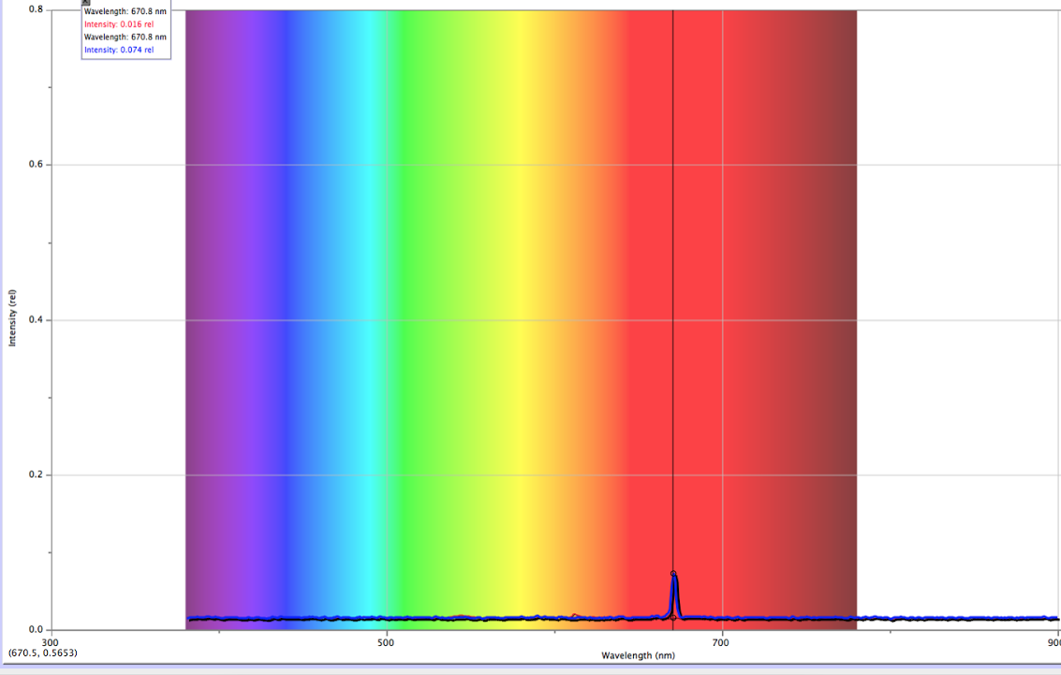

Figure 6: Intensity vs. Wavelength for Unknown 3

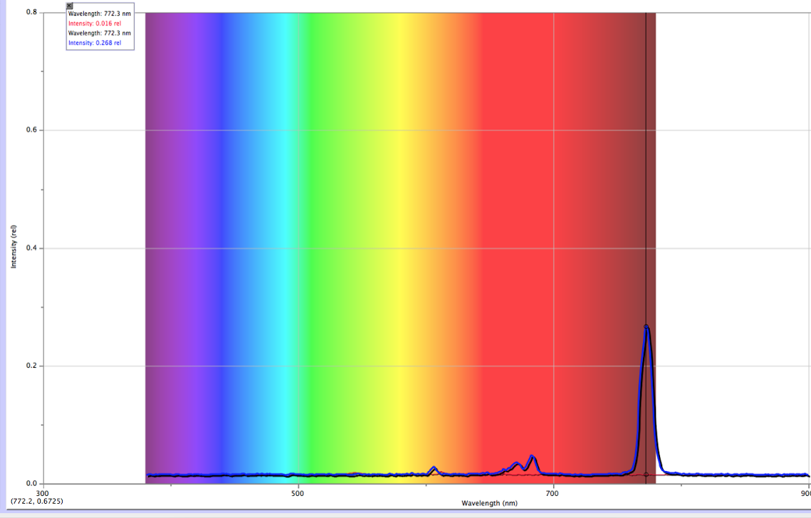

Part II Discussion:

The purpose of part 2 of the experiment was to measure and record the wavelengths and intensity of known and unknown substances using a spectrometer. This allows us to discover the unknown substances in comparison to the known substances. In order to execute this experiment, a spectrometer was held near the flame and the analysis was displayed on a computer screen in order to visualize the spectrum in graphical terms.

It is possible to detect one metal in presence of another using spectroscopy by recognizing the smaller yet significant peak wavelengths. For example, the SrCl ² has multiple wavelengths, one at roughly 600 nm and the other at roughly 790 nm which could indicate that there could be more than one metal in the substance.

The highest wavelength was captured by a screenshot. KCl showed the longest wavelength to be 773.1 (Figure 4), and the unknown substance emitted the longest wavelength of 772.1 (figure 6). Because these wavelengths are so similar, it can be interpreted that Unknown 3 contained K (Potassium) and Cl (Chlorine). Although KCl had a higher intensity than Unkown 3, this solely means that the spectrometer was held closer to the flame when measuring KCl. The small amount of differentiation between the two wavelengths of KCl and Unknown 3 supports a high confidence in the accuracy of this claim. The use of a spectrometer being an accurate device, also allowed little room for inaccurate date.

The peaks on an Intensity vs. Wavelength graph relate to emission lines like those seen in a spectroscope because the strongest wavelengths are the ones that are most significant. For example, purple and blue have a higher frequency of wavelengths, which means that their emission spectrum is more intense. These wavelengths are also crucial for identifying an unknown element.

Part III:

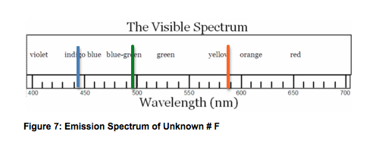
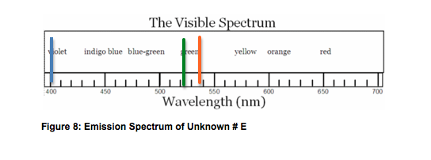
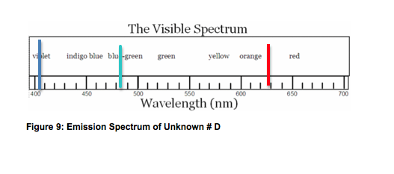

Figure 10: Visible Spectrum of Known Elements
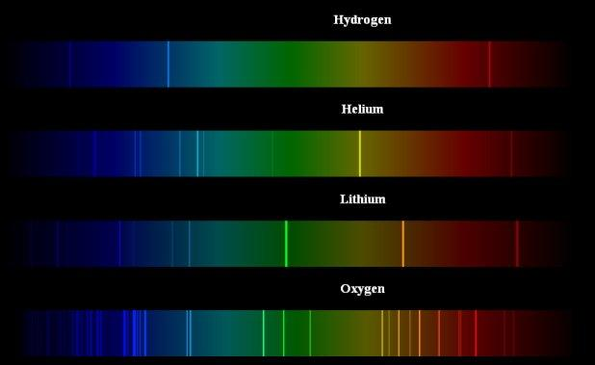

Part III Discussion:

The purpose of part 3 of the experiment was to identify three unknown substances throughout the process of tube analysis using a spectroscope and identifying the unknown substances by comparing color spectra's to already existing elements. When light was emitted onto the spectroscope, the light was broken up and translated onto the visible spectrum. The first unknown emission spectrum (Figure 7: Unknown #F) was identified as Lithium. The spectrum of Unknown #F displayed purple, green, and orange on the visible spectrum. The particular alignment and colors matched the visible spectrum of Lithium. (See figure 10). Both Unknown #F and Lithium appeared to have a peak of green at approximately 500 nm, as well as an appearance of orange around 590 nm, which implies that Unknown #F is Lithium because of the similarities they share in the color spectrum. The second Unknown, unknown #E, showed a peak of blue at 410 nm, a peak of green at 520 nm, and a peak of yellow/orange at 540 nm. (Figure 8: Unknown #E). The unknown was identified as Helium, which also displays blue at approximately 400 nm as well. The green in the helium spectrum is faint, but still present, and at a similar place on the spectrum as the green was in Unknown #E. Helium also shows a peak of yellow at approximately 550 nm, where the Unknown #E showed yellow/orange. The third Unknown (Figure 9: Unknown #D) was identified as Oxygen. The unkown showed a peak of violet at 410 nm, a peak of blue/green at 480 nm, and a peak of red at 630 nm. All of which were similar peaks to those on Oxygen’s visible spectrum (See figure 10). Oxygen displays a vast aroma of vibrant colors, similar to the peaks on Unknown #D.

When you are using a spectroscope to observe emission lines you are not seeing the entire emission spectrum, simply because some of the spectrum is not visible to the human eye, such as infrared and ultraviolet. The strongest wavelengths are the colors that show up with the most intensity.

Helium displays two blue lines at the far left of the spectrum, a yellow line in the center of the spectrum and a red line to the far right of the spectrum. Because of the position of the yellow line, it would be difficult to detect Na because it displays a yellow line in the middle of the spectrum as well. It would be possible to detect the presence of an element that did not have lines overlapping helium.

Spectroscopy was used to prove the existence of a previously unknown element, which is now known as Cesium. The lines on the color spectra that were crucial in identifying cesium, were disguised by the lines of the elements lithium, sodium, and potassium. When the other elements were removed from the experiment, cesium was revealed, allowing its prominent color lines to be identified. Spectroscopy is important because it can be useful in identifying unknowns, once it is by itself or in the presence of an element that does not overlap or hide any potentially unknown substance.

There are errors that may have occurred during the analysis that could have interfered with the accuracy of the analysis and precision of wavelength measurement. For instance, the impurity of a substance could have affected the spectroscopy measurement and the color of the flame. If the substance was slightly mixed with another substance, this would have created inaccurate flame color. In order to improve this lab, precautions could be included to ensure that tested compounds were not contaminated. An experiment that could be done beyond this introductory lab would be: Honeybees are dying all over the world, and determining the reasoning behind it is difficult. Could spectrometry be used to test honeybee honey and be tested in a hive to gain insight into what chemicals are making it into honeybee hives and are these chemicals impacting the health of the honeybees?

Honors extension:

Atomic Absorption Spectroscopy is used to determine concentration of a certain element. It was originally used as an analytical technique. It is primarily used to determine multiple types of chemical elements in their gaseous states. This technique is a measurement of concentration of atoms by using the characteristic that atoms obtain which is the absorption of light. Atomic Absorption Spectroscopy differs from the traditional evaluation of atomic emission lines, because it makes overlap rare, and allows us to to accurately identify elements within samples. The substances with known analyte content can be used to create a relationship and comparison between the measured absorbance of light and the analyte concentration. The analyte concentration is identified from the absorption of light within the atom. The absorption of light is associated with the speed of light through the material it is traveling through. Transmission of light through a substance is dependent upon the transmission of light through the particular substance. The wavelength measurement corresponds with a specific element. In order to specify the elements accurately, the elements must absorb energy and be evaluated precisely to be identified. Generally, as concentration of a single element in a solution increases, the absorption increases as well.

